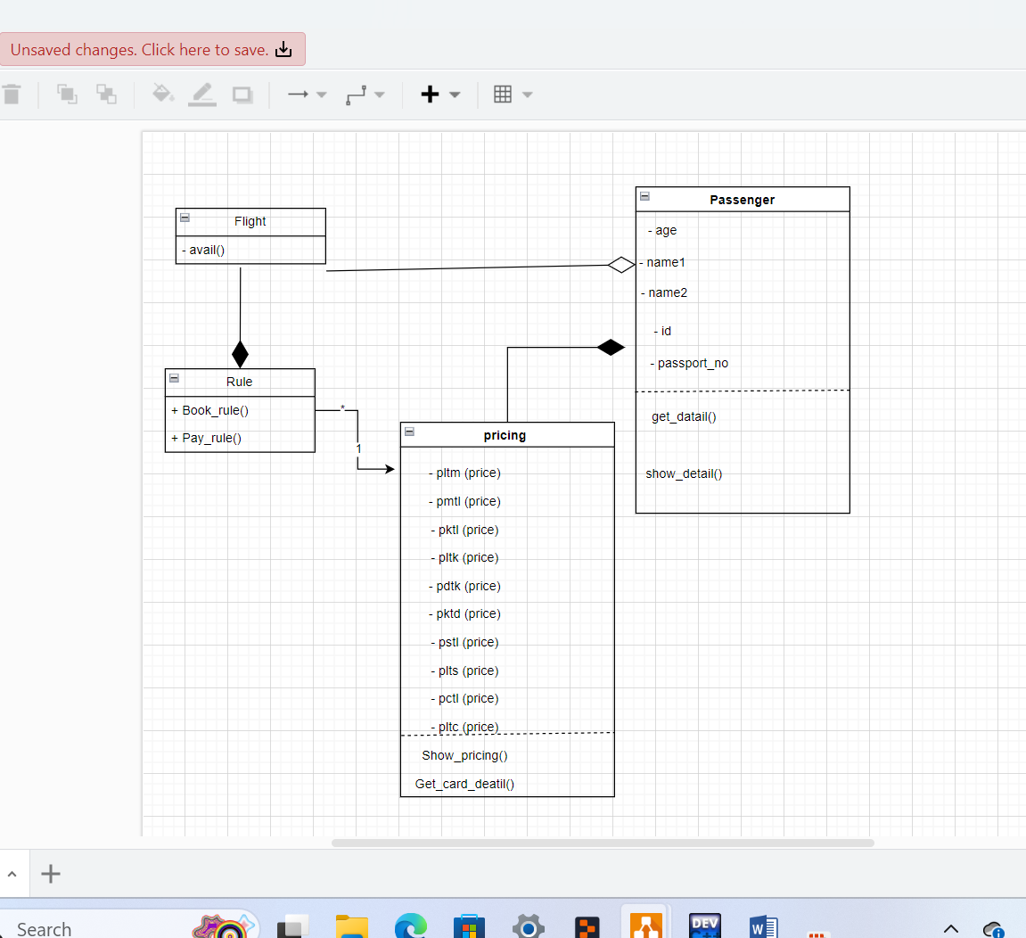

**Class: flight**

- **LtM, MtL, KtL, LtK, DtK, KtD, StL, LtS, CtL, LtC**:

Integers representing the number of flights available between specific cities (e.g., Lahore to Multan, Multan to Lahore, etc.).

**- seats:** Integer representing the number of seats reserved by a customer.

**- select`:** Integer for storing the selected flight option by the customer.

**- choice`:** Character representing the user's choice for the flight route.

**- flight ():** Default constructor initializing flight routes with default number of flights.

**- flight (int a, int b, int c, int d, int e, int f, int g, int h, int i, int j, int s):**

Parameterized constructor to initialize flight routes and seat count.

- **avail()**: Member function displaying available flights, accepting user input for flight selection, and seat reservation process.

**Class: passenger**

**- age:** Integer representing the age of the passenger.

**- name1**: String for the passenger's first name.

**- name2**: String for the passenger's last name.

**- id:** Long integer representing the passenger's ID.

**- passport_no:** Long long integer representing the passenger's passport number.

**- get_detail():** Member function to input and store the passenger's details.

**- show_detail():** Member function to display the passenger's details.

**Class: pricing**

**- digitCount:** Integer to count the number of digits in the card number.

**- cvv_count**: Integer to count the number of digits in the CVV.

**- pmtl, pltm, pktl, pltk, pdtk, pktd, pstl, plts, pctl, pltc:**

Integers representing the ticket prices for different routes.

**- card_number:** Long long integer representing the card number.

**- cvv:** Integer representing the CVV number of the card.

**- MM, DD, YY:** Integers representing the card's expiration date (month, day, year).

**- pricing():** Default constructor initializing ticket prices for different routes.

**- show_pricing():** Member function to display the ticket prices for different routes.

**- get_card_detail():** Member function to get and validate the card details for payment.

**Class: Rules**

**- BookRules():** Member function to display the flight booking rules and regulations.

**- PayRules():** Member function to display the payment rules and regulations.